Study and familiarization of the basic logic IC’s (OR, AND, NOT, NOR, NAND, XOR, XNOR) and Universality of NAND & NOR GATE
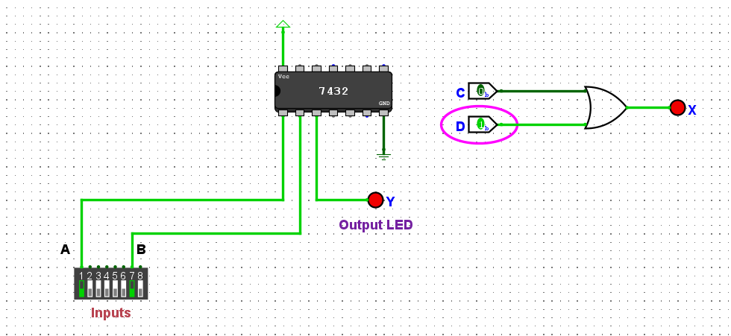

A | B | X
0 | 0 | 0
0 | 1 | 1
1 | 0 | 1
1 | 1 | 1

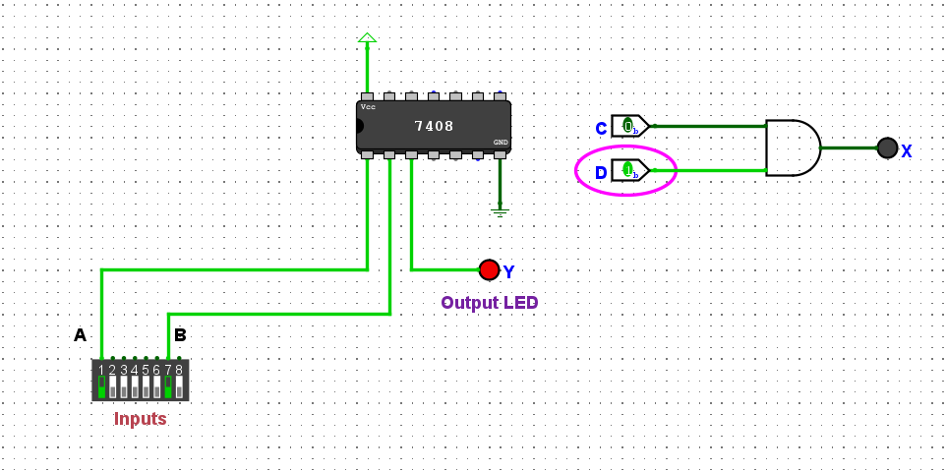
Figure 1: OR Gate (7432) Connect diagram with Truth Table

A | B | X
0 | 0 | 0
0 | 1 | 0
1 | 0 | 0
1 | 1 | 1

Figure 2: AND Gate (7408) Connect diagram with Truth Table
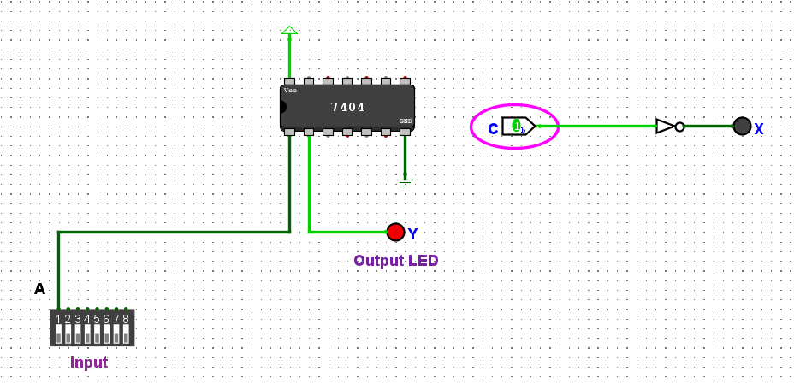

A | X
0 | 1
1 | 0

Figure 3: NOT Gate (7404) Connect diagram with Truth Table
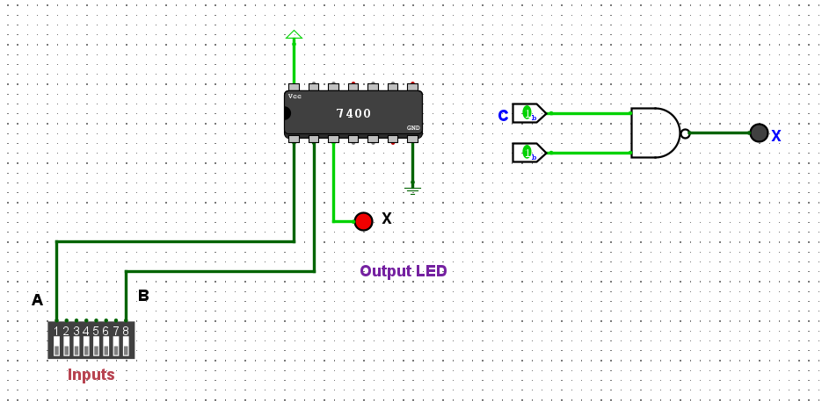

A | B | AB | (AB)’
0 | 0 | 0 | 1
0 | 1 | 0 | 1
1 | 0 | 0 | 1
1 | 1 | 1 | 0

Figure 4: NAND Gate (7400) Connect diagram with Truth Table
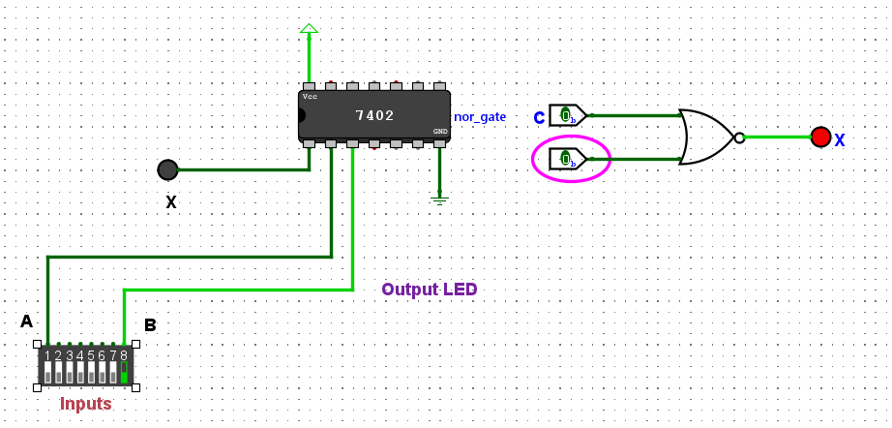

A | B | A+B | (A+B)’
0 | 0 | 0 | 1
0 | 1 | 1 | 0
1 | 0 | 1 | 0
1 | 1 | 1 | 0

Figure 5: NOR Gate (7402) Connect diagram with Truth Table
A | B | A’ | B’ | A’B | AB’ | A’B+AB’
0 | 0 | 1 | 1 | 0 | 0 | 0
0 | 1 | 1 | 0 | 1 | 0 | 1
1 | 0 | 0 | 1 | 0 | 1 | 1
1 | 1 | 0 | 0 | 0 | 0 | 0
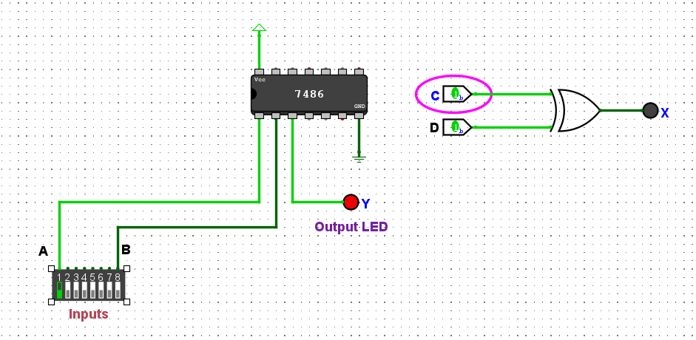

Figure 6: XOR Gate (7486) Connect diagram with Truth Table
A | B | A’ | B’ | AB | A’B’ | AB+AB’
0 | 0 | 1 | 1 | 0 | 1 | 1
0 | 1 | 1 | 0 | 0 | 0 | 0
1 | 0 | 0 | 1 | 0 | 0 | 0
1 | 1 | 0 | 0 | 1 | 0 | 0
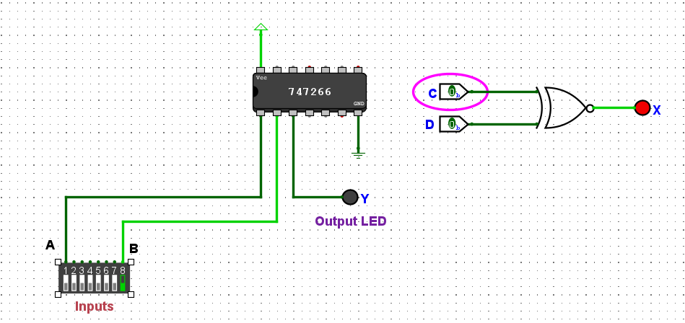
Figure 7: XNOR Gate (747266) Connect diagram with Truth Table

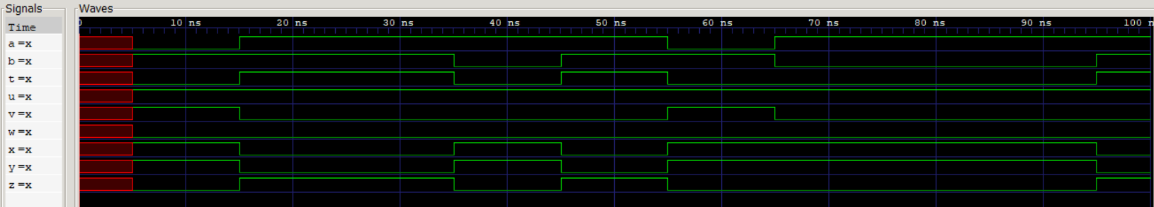
Figure 8: Basic Logic Gate Operations
The following Verilog assignments illustrate the fundamental behavior of digital logic gates using two input variables, a and b. The signal t represents the AND operation (a & b), producing a high output only when both inputs are high. The signal u corresponds to the OR operation (a | b), which outputs high if either input is high. The signal v is the inversion of a (~a), while w performs the NOR operation (~(a | b)), yielding high only when both inputs are low. Similarly, x implements the NAND operation (~(a & b)), which is low only when both inputs are high. The signal y denotes the XOR operation (a ^ b), producing high when the inputs differ, and z represents the XNOR operation (~(a ^ b)), which is high when the inputs are equal. Together, these assignments demonstrate the essential logic functions and their inverted forms, forming the basis of digital circuit design and verification.

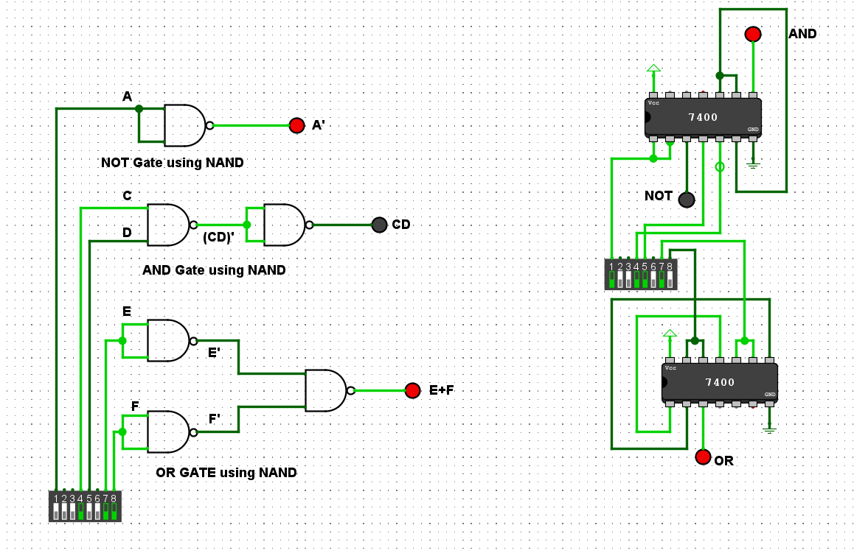
Figure 9: Universal Gate Implementation Using NAND Gates
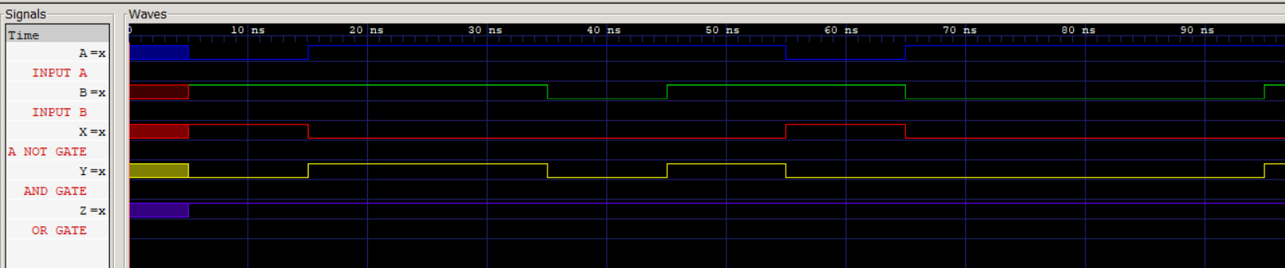
Figure 10: Verilog Simulation of NAND-Based Universal Logic
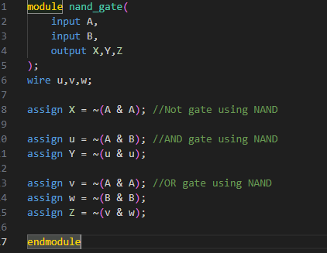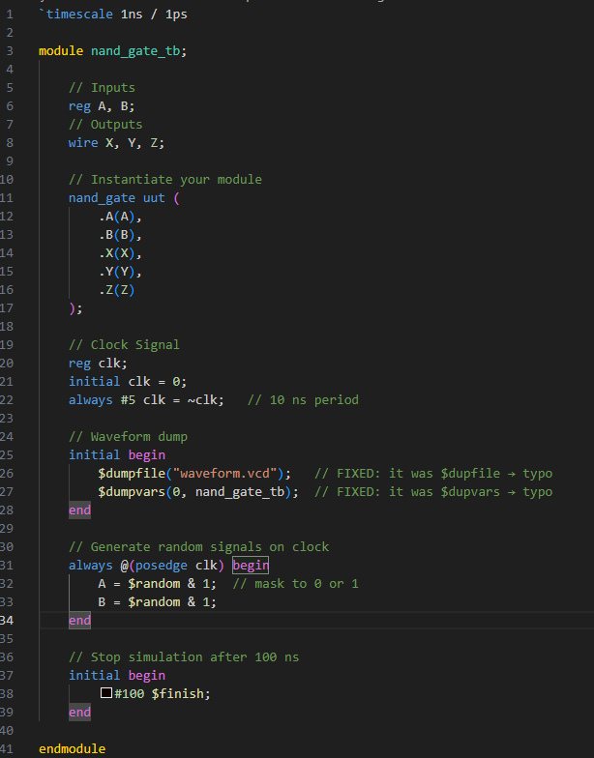
Figure 11: Verilog Code
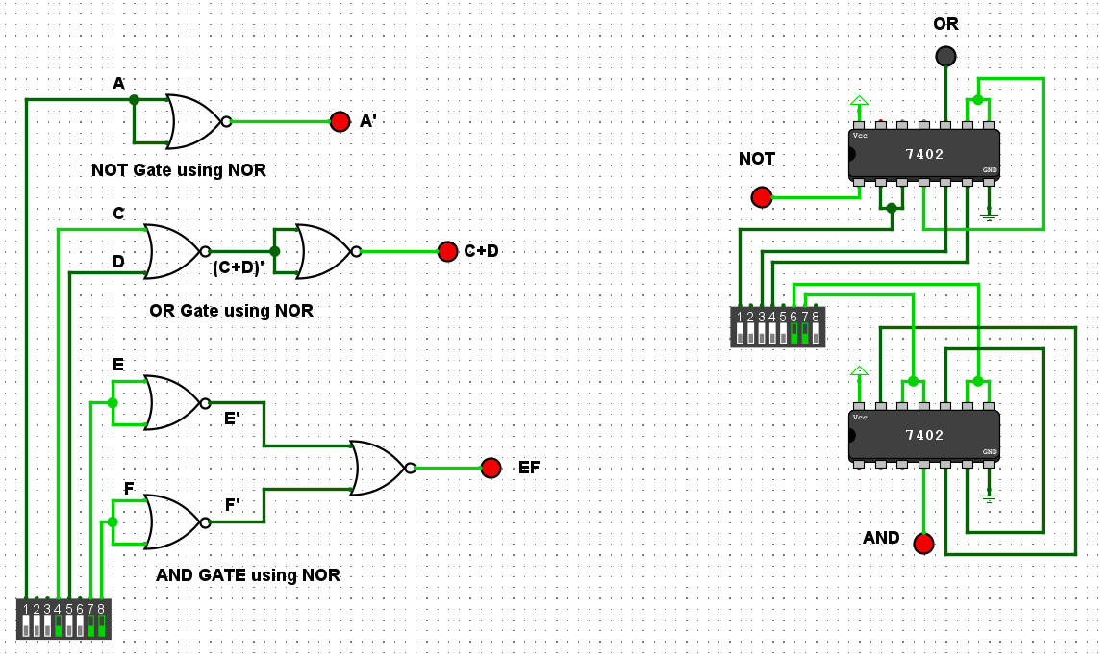
Figure 12: Universal Gate Implementation Using NOR Gates
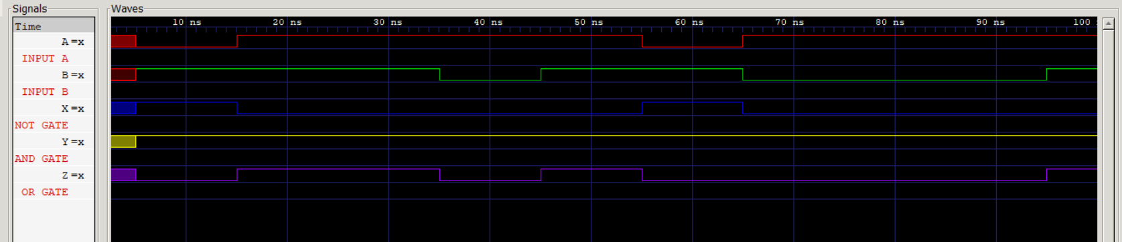
Figure 13: Figure 10: Verilog Simulation of NOR-Based Universal Logic
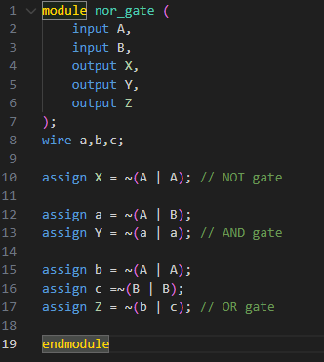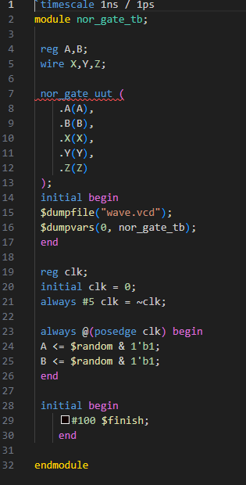
Figure 14: Verilog Code

